A: for the value 455, the optimal arrangement is 91 + 91 + 91 + 91 + 91 (5 bills) however a greedy approach results in the arrangement 365 + 52 + 28 + 7 + 1 + 1 + 1 (7 bills)

C:r(k) = Minimum ( r(k - b[i]) ) + b[i], where b is the set of bill values and 0 < i < | b |

D: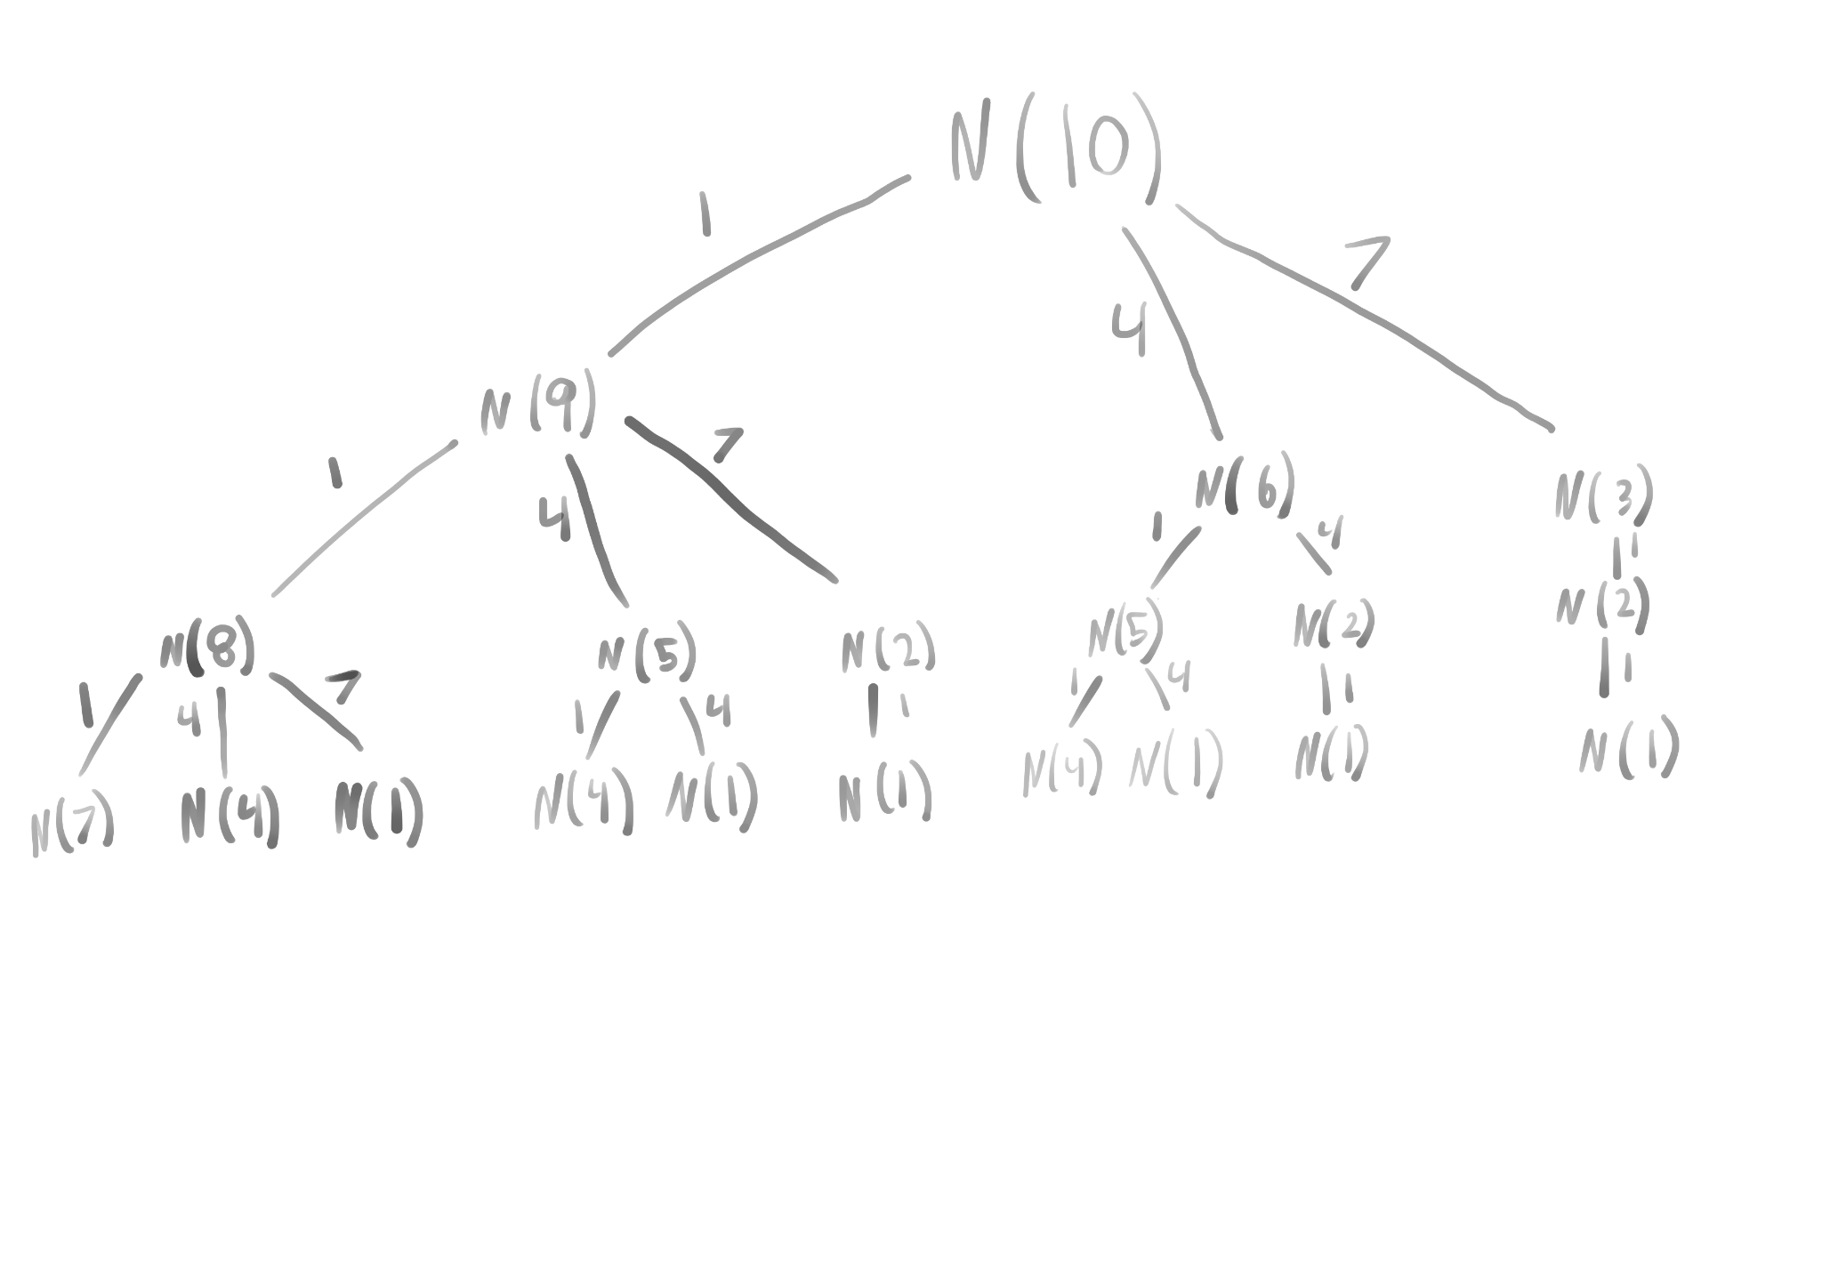

N(4): 3 calls

N(0): 20 branches

E: 3 bills, 7 + 1 + 1 + 1

H: O(n)

I: O(n)